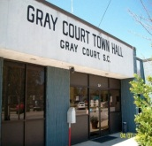
COUNCIL MEMBERS MAYOR Stellartean Jones

Millie Dawkins
Laura Cook Doris Hamilton, Clerk/Treasurer
Dylan Cook
Charles Thomas Columbus Stephens, Town Administrator

Gray Court Town Council Special Call Meeting
June 4, 2026
6:00 PM
Agenda

-CANCELLED-

- Call to Order - Mayor Stellartean Jones

- Invocation & Pledge –

- Business –
- Gray Court Community Park – Concession Stand and Grilling
- Grass Mowing – Private Property
- Maintenance Employee – Hired June 1, 2026
- Intergovernmental Agreements
- Garbage Pickup
- Budget FY’ 2026-2027 Special Call Meeting

- Adjournment

329 Main Street – P.O. Box 438
Gray Court, South Carolina 29645
Telephone - (864) 876-2581 Fax – (864) 876-3999
Incorporated in 1899 • “We are striving to improve”

